USER INTERFACE DESIGN

# EXP.NO:1

TASK:TO TAKE A BAD DESIGNED USER INTERFACE FROM BROWSER AND MAKE A GOOD DESIGN USING FIGMA

REG.NO:230701246 DATE:25.01.2025

DESIGN NO.1:

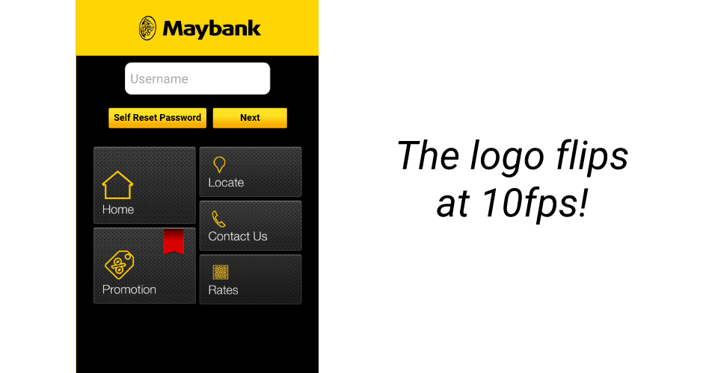BAD DESIGN : GOOD DESIGN:

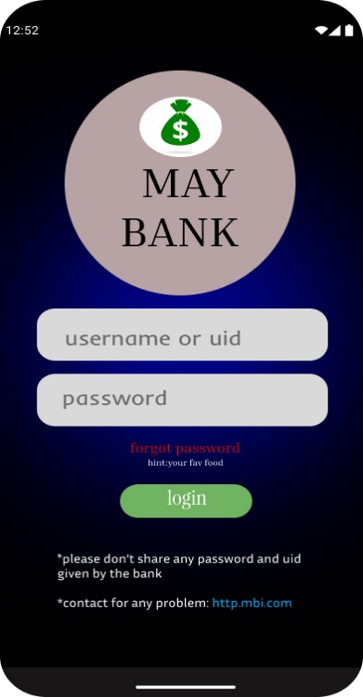

WHY IT IS BAD ? : The black background with yellow text/buttons strains the eyes and lacks sufficient contrast. Buttons and navigation tiles have equal visual weight, confusing the flow. Mixed styles (gradient buttons vs. textured tiles) create an unpolished look. Navigation tiles lack clear labels or context for their purpose.

WHY IT IS BETTER: The clean and simple layout focuses on the essential elements, reducing distractions.The username, password fields, and login button are prominently placed, guiding the user through the process.The color scheme and fonts are consistent, creating a polished and cohesive look.Helpful hints like "forgot password (hint: your fav food)" and instructions make the interface more user-friendly.

DESIGN NO.2:

BAD DESIGN: BETTER DESIGN:  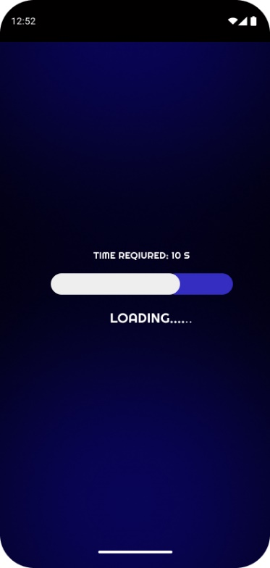

WHY IT IS BAD :The interface is overcrowded with too many options, images, and icons, making it overwhelming and hard to navigate. Important elements like "Login" or "Mobile Transfer" are not clearly highlighted compared to secondary features like "Promotions”. Mixing text, icons, and large images creates a disorganized and unprofessional appearance .The menu on the left and the tiles below compete for attention, confusing the user's flow **.**The "Loading..." text appears misplaced and does not indicate progress effectively, causing potential confusion or frustration .The design wastes valuable screen space by including large images that do not add functional value, reducing efficiency.

WHY THIS IS BETTER : The clean and simple layout avoids clutter, ensuring a smooth user experience .The dark blue background contrasts well with the white text and progress bar, improving readability .The "TIME REQUIRED: 10 S" and "LOADING..." messages inform users about the process and expected wait time .The rounded progress bar with a gradient effect creates a visually engaging and modern look. The layout is well-optimized for mobile screens, with proper spacing, readable fonts, and a centered progress indicator, making it easy to use on various devices.

DESIGN NO.3:

BAD DESIGN: BETTER DESIGN:

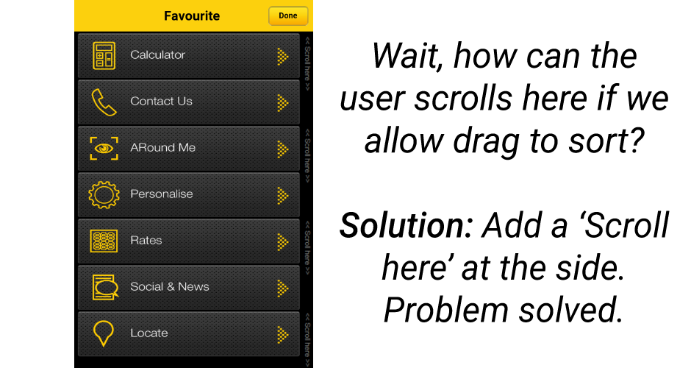 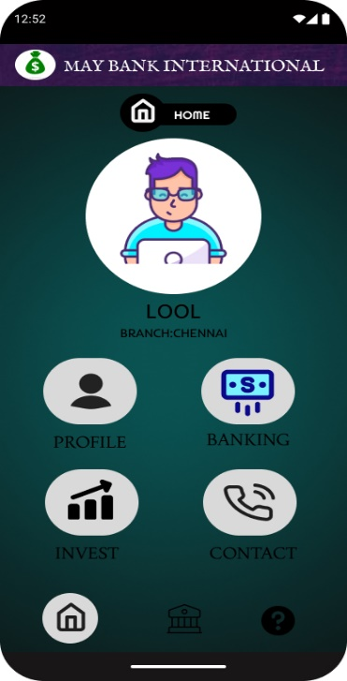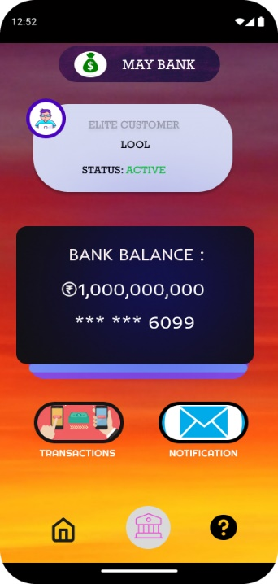

WHY IT IS BAD DESIGN:

Here are five key issues with this UI design:Light gray text on a dark background reduces readability, making it hard to read."ARound Me" has improper capitalization, making it look unprofessional.Some icons, like "Rates" and "Personalise," do not clearly indicate their function.The yellow arrows on each item add clutter without adding usability.The design looks outdated with glossy buttons and a gradient background.

WHY IT IS BETTER:

1. The text is more visible against the background, improving readability.The icons and labels are spaced out well, making it easier to navigate.Uses modern, flat icons with a simple and clean aesthetic.Icons for "Profile," "Banking," "Invest," and "Contact" are more intuitive and visually clear.The text appears uniform in size and capitalization, enhancing professionalism.
2. The design highlights important elements like the bank name, balance, and user status prominently, making it easy for users to identify key information at a glance.

The clean interface avoids clutter, allowing users to focus on essential actions such as checking balance and navigating via clear icons.The vibrant background with contrasting foreground elements ensures readability and enhances the overall aesthetic appeal.Icons for transactions, notifications, and other options are distinct and strategically placed, enabling quick and easy access to features.

DESIGN NO.4:

BAD DESIGN : BETTER DESIGN:

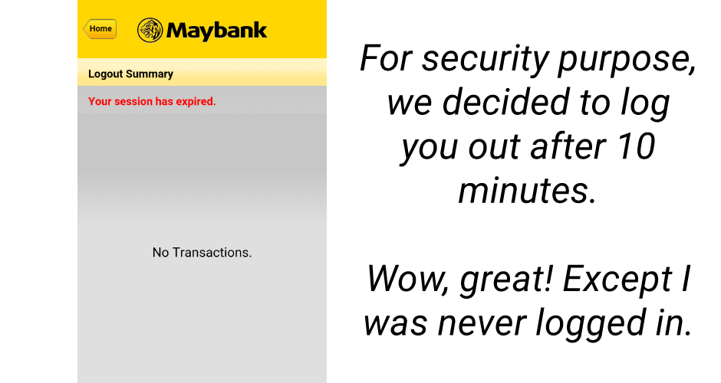 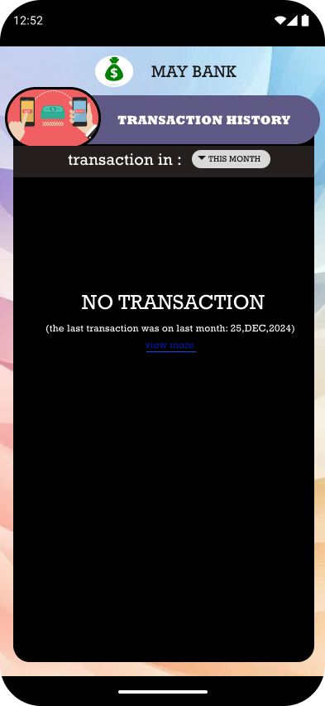

WHY IT IS BAD:

No option to re-login after "Session expired," leaving users stuck.Empty message "No Transactions" adds no value or guidance .Plain design lacks visual hierarchy and engagement .Poorly placed "Home" button with unclear functionality.

WHY THIS IS BETTER:

Displays the date of the last transaction, providing more meaningful feedback to users compared to "No Transactions ."Includes a "View More" button for exploring older transactions, improving user engagement. Uses a well-structured layout with clear sections and visually appealing color , making it user-friendly .Offers a dropdown to filter transactions by time period, enhancing usability and functionality.